PRESS RELEASE 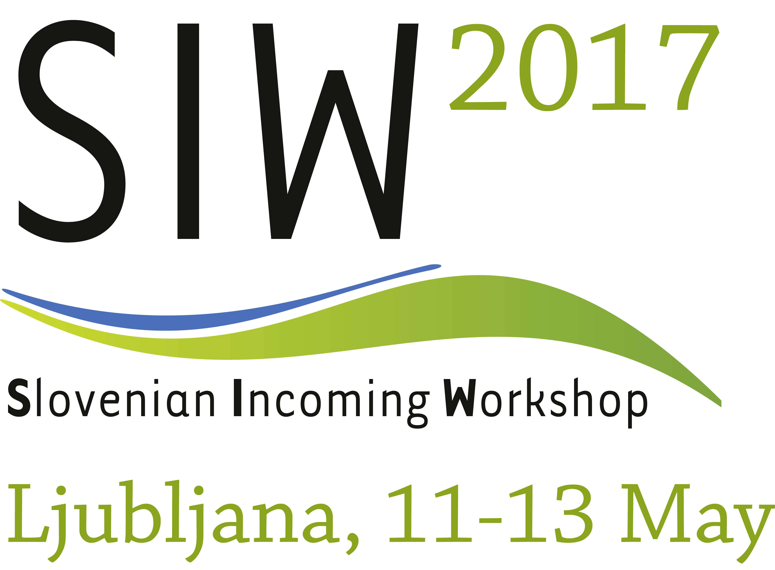

**Jubilee 20th Edition of the Slovenian Incoming Workshop**

*Ljubljana, 12 May* ***– The Slovenian Tourist Board (STB) has been organising the flagship event of the Slovenian tourist industry for twenty years.*** ***Featuring prearranged meetings between Slovenian tourism providers and foreign tour operators, the Slovenian Incoming Workshop (SIW) is an opportunity to strengthen successful partnerships and encourage new connections.This edition of SIW takes place in Ljubljana from 11 to 13 May. The programme also includes study tours through which foreign participants can discover the various destinations and tourism products that Slovenia has to offer.***

SIW represents a unique opportunity to present Slovenia's tourism offering to foreign tour operators, travel agents and specialised agencies, and other interested groups. Leading representatives of Slovenian tourism companies and organisations, hotels, tourist agencies, health resorts, the public tourism sector, conference centres and other operators in the tourism sector introduce themselves via prearranged 20-minute business meetings, while the informal meetings organised by the STB during SIW offer further opportunities for networking and discussions.

This year's 20th SIW takes place in Ljubljana. Participants include 220 representatives of the Slovenian tourism sector from a total of 130 companies and 188 representatives of 146 companies from other countries.

Of the foreign participants, 67% are attending SIW for the first time. They come from 42 countries, with the largest numbers coming from the Czech Republic, Italy, Austria, Germany, the United Kingdom and Croatia. This year also sees the first participants from Lebanon. SIW is also attended by companies from other continents, with representatives arriving from Japan, Indonesia, Malaysia, Australia, the USA and elsewhere. We expect at least 3,000 business meetings to take place during SIW.

The 20th edition of SIW officially began on Thursday, 11 May with a "Welcome to Ljubljana" evening. The main event takes place on Friday, 12 May, at the Grand Hotel Union. The official opening of SIW, at which participants were welcomed by Eva Štravs Podlogar, State Secretary of the Ministry of Economic Development and Technology, STB Director Maja Pak and Union Hotels General Manager Tomo Čeh, was followed by business meetings. Today's activities will end with a Slovenian evening at Ljubljana Castle.

Another important component of SIW are the study tours. These "field trips" give participants the opportunity to discover the various destinations and tourism products that Slovenia has to offer. This year a grand tour before the official start of SIW took participants to Slovenia's biggest tourist attractions. They will have a further opportunity to get to know our country on four different themed tours after SIW officially closes. The themes of the tours are the natural riches of Slovenia, wellness, outdoor activities and Plečnik's Ljubljana (including discovering local cuisine).

At this year's 20th edition of SIW, **Zdravko Počivalšek**, the Minister of Economic Development and Technology, expressed his satisfaction with the participation: *"I note with satisfaction that a growing number of tourism companies from Slovenia and abroad are attending the Slovenian Incoming Workshop each year. This means that this event has found its place in the business calendars of international tourism professionals.* *I am sure that the many conversations and meetings will bear fruit and that new business ties will be formed. Many companies have already recognised the Slovenian tourism sector as a reliable business partner and identified opportunities for the development of successful cooperation. For some who are attending this event for the first time this year, there is no doubt that Slovenia has been brought to their attention as an interesting tourist destination and potential business opportunity by the international awards and accolades that the Slovenian tourism sector has received both last year and this year. Such recognition is proof that tourism in Slovenia is developing in line with global trends, where we can confidently measure ourselves against the best."*

The official opening of SIW was followed by a press conference at which **Eva Štravs Podlogar**, State Secretary of the Ministry of Economic Development and Technology, referred to SIW as being the biggest bussiness event in the tourism industry in Slovenia: *"With its 20th anniversary, it is particularly gratifying to note that Slovenia has become a globally recognized tourist destination which attracts more and more interest. This year's SIW takes place in Ljubljana. This is just the right place to let the participants know that the next two years will be dedicated to cultural tourism and to encourage the Slovenian tourism stakeholders to develop innovative tourism products and services on the theme of culture. To raise the competitiveness of Slovenia as a tourism destination, innovative products with added value need to be developed, which is possible only by increasing the quality of services and integration. I wish all the participants of this year's 20th anniversary SIW successful and fruitful business day and a lot of success."*

*"We are encouraged by the fact that for 20 years now there has been great interest among foreign tour operators in the tourism offering of green, active, healthy Slovenia, which is increasingly establishing a reputation as a boutique destination for outstanding five-star experiences,"* said **Maja Pak**, the Director of the Slovenian Tourist Board. *"Over the course of all these years, the Slovenian Incoming Workshop has established itself as the Slovenian tourism industry's most important business event, one that offers time-efficient and effective meetings with numerous opportunities to conclude excellent deals and get to know a range of experiences around Slovenia. At the same time SIW is an opportunity to raise the profile of our country's tourism offering in foreign markets."*

Ms Pak went on to say that intensive final preparations for the programme of work for the next two years are currently under way at the STB, in conjunction with the tourism industry and other partners. The programme envisages the further enhancing and intensifying of promotional and marketing activities and the development of high-added-value tourism products. The numerous development and promotional activities planned by the STB in its ambitious programme of work for 2017 are also in full swing. Several presentations have already been made at tourism fairs and trade shows, with a further 17 fairs and 14 workshops and other business events to follow in Europe and overseas markets before the end of the year. A major digital campaign called ***SLOVENIA. Make New Memories.*** is currently under way in 13 foreign markets or groups of markets in a total of 21 countries via various websites and mobile sites. A new feature of this year's campaign is advertising on the digital platforms of the BBC and CNN. The advertising campaign aims to reach 80 million views. Another of this year's important projects is STB's involvement in the advertising, presentation and broadcasting of the Round Slovenia cycling race on the international channels of the Eurosport network.

At today's press conference, Maja Pak also presented some provisional figures from SURS, Slovenia's national statistics office: *"In the first quarter of this year Slovenian tourism has continued the positive growth in both domestic and foreign visitor numbers. Tourist arrivals from January to March were up by 7% and we recorded 5% more overnight stays than in the same period last year. Foreign tourists generated 5% more overnight stays, and domestic tourists 4% more. Inflow from travel exports for the first two months stands at 4%."*

The biggest shares of overnight stays were in municipalities with health resorts (37%), municipalities in mountain areas (26%) and coastal municipalities (13%). These were followed by Ljubljana (10%) and other city municipalities (8%). The ranking of the top 10 markets by number of overnight stays was headed by Italy, Austria, Germany, Croatia and Hungary. The countries showing the highest growth in the first quarter of this year include the Russian Federation (+37%), France (+36%), South Korea (+50%), Luxembourg (+46%), Poland (+39%), Latvia (+33%) and Sweden (+29%).

**Petra Stušek**, Director of Ljubljana Tourism, emphasized the importance of SIW for Slovenia and Ljubljana: *"This is already the 4th time for Ljubljana to host SIW. In addition to the business part, we will use this opportunity to present our rich gastronomy and culture. The jubilee edition of the Slovenian Incoming Workshop is a great opportunity for the participants to enjoy the vibrant pulse of the city. In our daily work and when participating in the events abroad, we see that the interest in Slovenia among the professional public grows, which is also confirmed by this year's large turnout of registered buyers from around the world. There are numerous newcomers among the participants, who will experience Slovenia and Ljubljana for the first time.”*

*******

The Slovenian Incoming Workshop (SIW) was born more than 20 years ago out of the desire for a professional event that would ensure the effective and innovative promotion of domestic tourism. **Iztok Altbauer**, today the director of the Natural Spas of Slovenia Association, was involved in its creation. *"In 1996 we founded the Tourism Promotion Centre of Slovenia, where I was head of the sales promotion department.* *We realised that we needed a professional event at which to bring together supply and demand. The following year we held the first SIW at a theatre in Maribor. The event was attended by 25–30 Slovenian tourism providers and around the same number of agents from other countries,"* remembers Iztok Altbauer, adding that the event's beginnings were quite humble. *"Nevertheless, we were able to map out a framework, which we then expanded with our team and the contacts we had made at fairs and other events over the course of the year. In this way we were able to begin more targeted invitations and to conclude various partnerships. From Maribor, where the second edition also took place, SIW began to move around Slovenia, in this way ensuring the diversity of the offering and giving participants the opportunity to get to know different destinations. It was our ambition from the very beginning that SIW should become the most important business event of the Slovenian tourism sector, and this ambition has been achieved. With a programme of different tours around Slovenia, the event combines a business element with the elements of presentation and connection. Today, the use of modern tools to set up and coordinate prearranged meetings enables optimal organisation; the SIW team and local providers work hard to ensure that this is a truly unforgettable event."*

For more information about SIW visit: <https://www.slovenia.info/en/business/business-events/slovenian-incoming-workshop-siw-2017>

**Additional information**

**Slovenian Tourist Board**

Dimičeva 13, SI-1000 Ljubljana, Slovenija

Tel.: 00386 (0)1 5898 550, Fax: 00386 (0)1 5898 560

[www.slovenia.info/press](http://www.slovenia.info/press)

Rebeka Kumer Bizjak, Global Public Relations, [press@slovenia.info](mailto:press@slovenia.info)

**Follow and visit us**

|  |  |
| --- | --- |
|  | * Visit the official **SLOVENIAN TOURIST INFORMATION PORTAL**: **www.slovenia.info** * Visit our **PRESS CENTRE**, follow the news (press releases) and monthly news for journalists: **www.slovenia.info/press** * Sign up for **MONTHLY NEWS FOR JOURNALISTS**: **www.slovenia.info/news** * Visit our **PHOTO GALLERY**, where you can view and use more than 1500 high-resolution photos of Slovenian tourism: **www.slovenia.info/photo** |