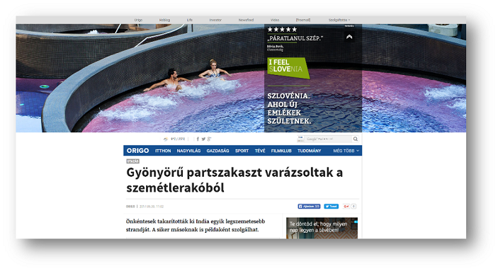

PRESS RELEASE

Global digital campaign again exceeds all expectations and reaches 117 million people

Ljubljana, 24 November 2017 – The global digital campaign aimed at raising the visibility and reputation of Slovenia as a green, active and healthy tourist destination, the promotion of attractive tourist products and increasing the competitiveness of Slovenian tourism yet again yielded exceptional results. Between 19 April and 15 November, the campaign reached almost 117 million people through various digital channels.

This year’s campaign surpassed all expectations and was, similarly to last year’s campaign, organised in cooperation between the Slovenian Tourist Board (STO) and the Slovenian tourist economy. The campaign took place between 19 April and 15 November in 21 countries and in 13 languages in the form of display (banners, video ads, backgrounds and similar) and content advertising (articles, micropages, infographics, quizzes, etc.) on 10 different digital channels and in 41 wide-reaching media (e.g. Der Spiegel in Germany, Kleine Zeitung in Austria, BBC in Great Britain and Ireland, CNN in the USA and Canada) or in specialised media (e.g. Bergfex in Germany).

The campaign reached almost 37 million people on various portals; more than 50 million (and over 107,000 new likes) via Facebook and more than 14 million people through Instagram, which was more than surprising. The objective was to obtain at least 1.5 million users and 10,000 new followers through this increasingly popular network; however, the campaign actually reached 14 million people and obtained several tens of thousands of new followers.

The response was also astonishing on the YouTube channel: almost 10 million advertisement displays (instead of the anticipated 3 million) and over 4 million of all views. All expectations were also exceeded by VKontakte, which reached over 10 million users (instead of the anticipated 5 million) and LinkedIn, with over 3 million advertisement displays (we anticipated 800,000). Search advertising through Google and Russian Yandex reached over 600,000 users (we anticipated at least 300,000). The novelty of this year’s digital advertising was the inclusion of native and video programme advertising, and addressing the users of social networks with these, more credible contents.

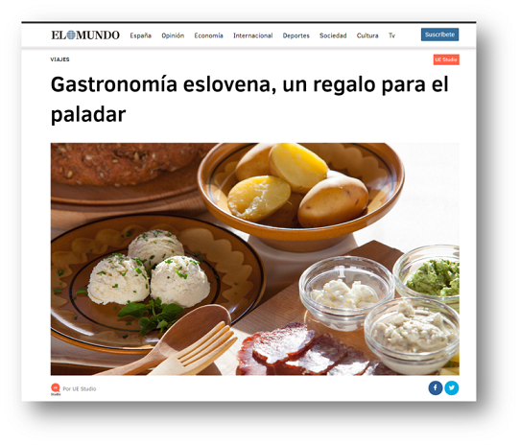

http://www.bbc.com/storyworks/travel/seeing-green/slovenia-tourism-infographic

During the digital campaign, visits to the website www.slovenia.info, to where the advertisements led, increased by 200 per cent in comparison to the previous period. The largest increase of visitors to the website was noticed in June, when almost 48,000 web visitors were recorded in one day. The findings of the campaign reveal that the greatest response to the digital campaign was in the markets of Italy, the USA, Canada and Spain. Due to the increased use of smart phones, the access to contents via mobile phones also increased. Advertising through mobile phones is attaining better results and a higher level of interaction.

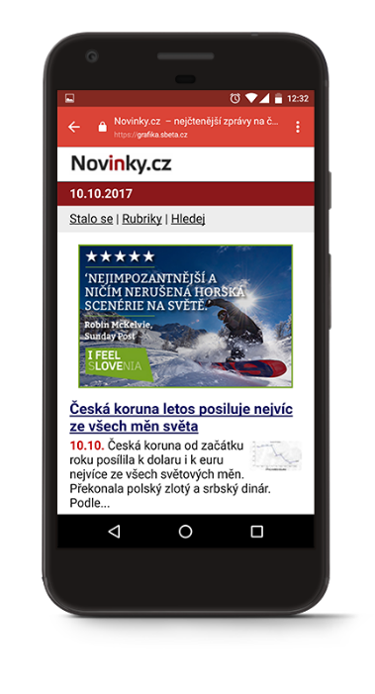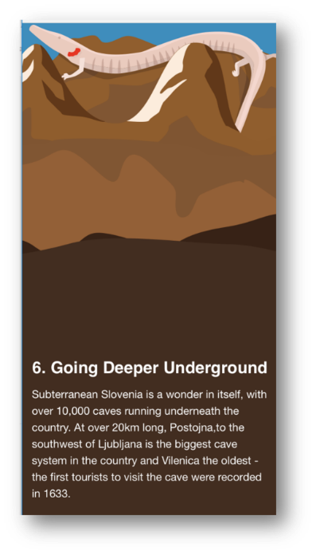

The added value of the implemented digital campaign lies particularly in the mutual cooperation of the STO and the Slovenian tourist economy through the presentation of almost 400 different tourist packages from providers featured on landing pages of the digital campaign and the translation into six languages.
"I am pleased that this year’s complex global digital campaign exceeded all the objectives set and has proven to be more than successful in the promotion of Slovenia as a green, active and healthy tourist destination, and has also contributed to the raising of its reputation and increased visibility. Countries are dedicating more and more funds to digital content marketing, since it is becoming one of the most important promotional tools. The Slovenian Tourist Board is aware of this promotional trend and so will pay particular attention to digital content marketing in the future. We will thus continue with this form of native advertising with interactive content on premium portals in 2018. Further attention will be dedicated to Instagram as the number of its users is growing, and to advertisements adjusted for mobile phones. This year’s campaign has revealed that as many as 46 per cent of clicks were done with the use of mobile phones," said mag. Maja Pak, Director of the Slovenian Tourist Board.

Additional information

Slovenian Tourist Board
Phone: +386 (0)1 5898 550, Fax: 01 5898 560
Livija Kovač Kostantinovič, Marketing Communications and Public Relations livija.kovac@slovenia.info
FOLLOW US AND OBTAIN MORE INFORMATION:

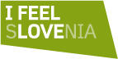  www.slovenia.info/facebook  www.slovenia.info/twitter  www.slovenia.info/linkedin  www.slovenia.info/youtube  www.slovenia.info/instagram  www.slovenia.info/googleplus  www.slovenia.info/pinterest  www.slovenia.info/tripadvisor | - Official SLOVENIAN TOURIST INFORMATION PORTAL: www.slovenia.info  - PRESS CENTRE: www.slovenia.info/press  - Subscribe to WEEKLY TPA NEWSLETTER: www.slovenia.info/sl/novinarsko-središče/tta-novice  - MEDIATEKA with over 3,000 high-resolution photographs depicting Slovenian tourism: www.slovenia.info/sl/mediateka

