News from Slovenia: Let's talk Instagram

Slovenia through the eyes of the best Instagram influencers and top-notch photographers

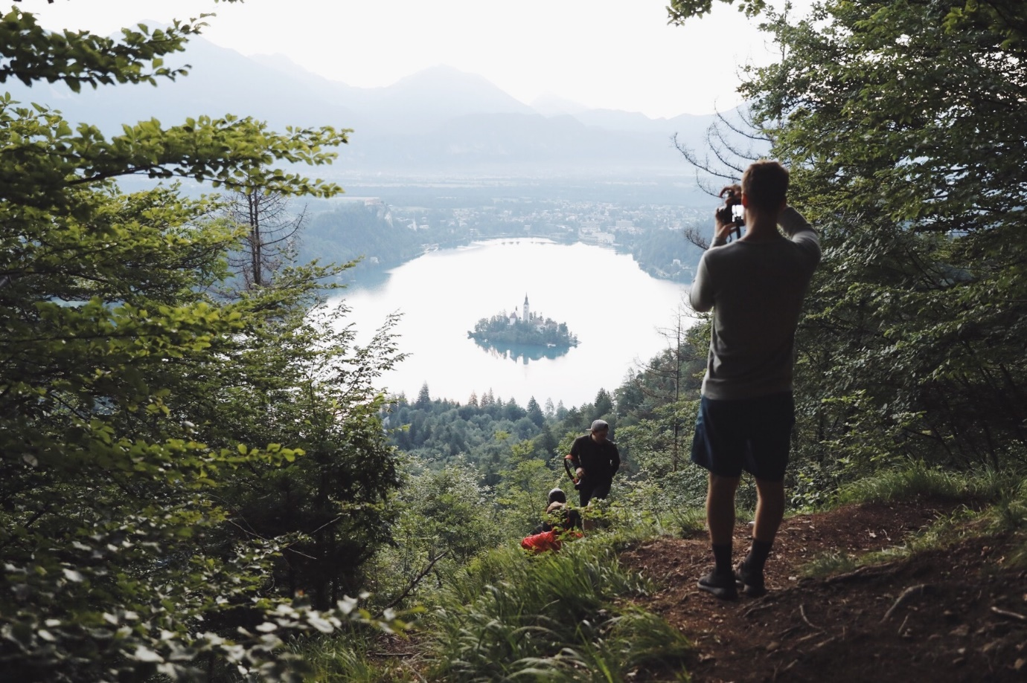

8 influencers from 4 countries, almost 3 million followers

We are proud to tell you that some of the best Instagram influencers and experienced photographers are zig-zagging around Slovenia right now, searching for the hidden corners of this tinny and diverse country.

Instagram as the most effective social media marketing platform
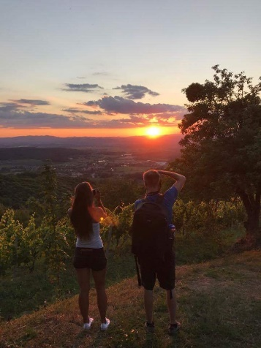
A sharp rise to travel marketing stardom for Instagram has been detected this past year. It’s no wonder: Instagram has everything you need to connect with travellers. People are willing to engage with brands and they even log in to this network specifically to use its location feature and find their next travel destination. It is thus important for the national tourism board to use these advantages and use these features to promote destination.
The Slovenian Tourism Board has focused on digital marketing and the results are clear: tourism is booming, people are amazed by the beauties of this tinny diverse country – there is so much to share! At the same time, digital influencers provide us with amazing high quality photos which can be used also for the off-line marketing purposes. Their photos are amazing, pinpointing all the features that make Slovenia unique and represent it as green, active and healthy country.

Slovenia is a gorgeous place!

We have invited some of the world’s best Instagram influencers to discover Slovenia. So far, they have been amazed. Arriving at the Ljubljana airport and most of them being the first-time visitors to Slovenia, we couldn’t but ask them what their first impression about Slovenia is. Can you guess the answer?

Here’s what Daniel Taipale, www.instagram.com/dansmoe, has to say:

I'm just impressed how gorgeous this place is. The nature is incredible from colorful rivers to high mountains. The locals are super friendly and we feel very welcome here.

Eeva Mäkinen, www.instagram.com/eevamakinen, says she had heard so much nice things about this place and within first day they were all proved to be true. Such a beautiful place. Lakes offer so much from sunrise to sunset and even between. I could stay only in this area for a week!

Let us recall – the first country in the world to be declared a green destination
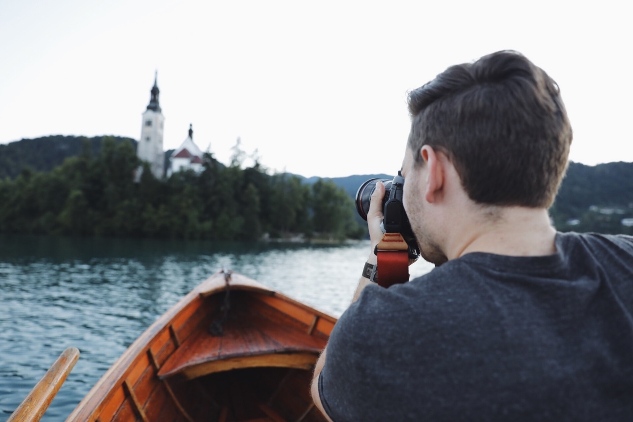

Slovenia is the first country in the world to be declared a green destination based on the Green Destinations Criteria. Situated in the heart of Europe, Slovenia is a boutique country between the Alps, Mediterranean Sea, mysterious Karst with more than 11,000 karst caves and Pannonian Plain, rich in healthy water springs. It’s a real Instagram paradise and to do it justice, inviting Instagram influencers is the right thing to do.

Who’s who?

Eeva Makinen and Daniel Taipale from Finland.

Daniel Ernst and Johannes Becker from Germany.

Ben Prescott and Andrea Ference from Canada.

Michael Matti and Jessica Dales from the States.

What are they going to see?

Divided into three different groups, altogether reaching almost 3 million followers, they are exploring the Slovenian landscape, focusing on natural features in different regions. Their daily adventures can be followed on their Instagram profiles and after the trip, they will also post the photos, which emphasize the diversity of the country. If you’re in Slovenia right now, you might even meet them while they zigzag across Slovenia.

Diversity on every step, overwhelmed by the beauties of the country

Eeva Makinen, Daniel, Johannes and Daniel are exploring the Julian Alps, while Ben, Jessica, Andrea and Michael stayed the first night in Krvavec (and even hiked to Zvoh, the highest point, early in the morning, before the sunset!). They continued towards Kamnik and then split into two parts: Ben and Jessica stayed on Velika planina, in one of the unique alpine huts, which herders usually stay at during the grazing season and continued to Logar Valley, and further on to Podpeca, where they went biking and kayaking in the mine. They spent the afternoon in Celje and today, they are continuing towards Maribor and Ptuj. Michael and Andrea explored the Dolenjska region and started the day with a breakfast on kanu (check their Stories on Instagram!) and continued to Škocjan Caves, Postojna Cave (which Michael described as one of the most unique places in the world). They spent the night on the coast, where they are exploring the Sečovlje saltpans. Afterwards, the four of them will meet in Kranjska Gora and continue their adventure in Soča Valley, finishing up in Ljubljana, the green capital of Slovenia.

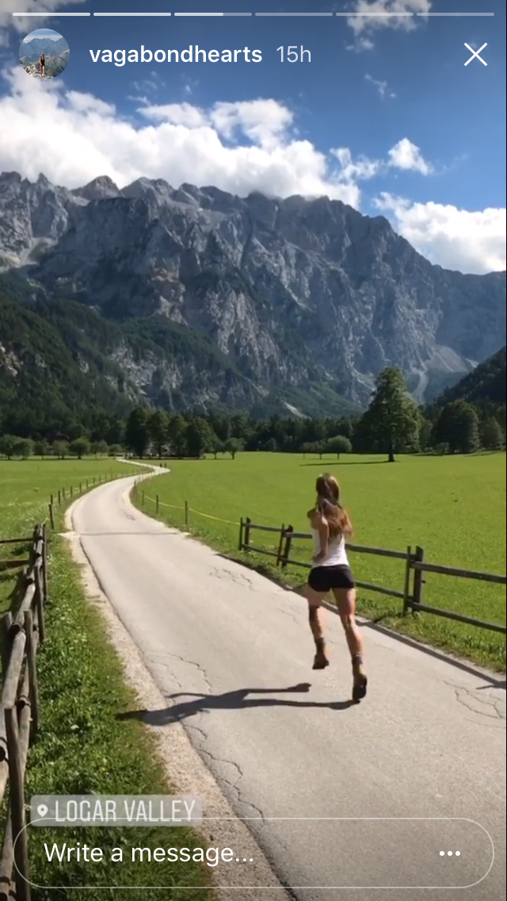

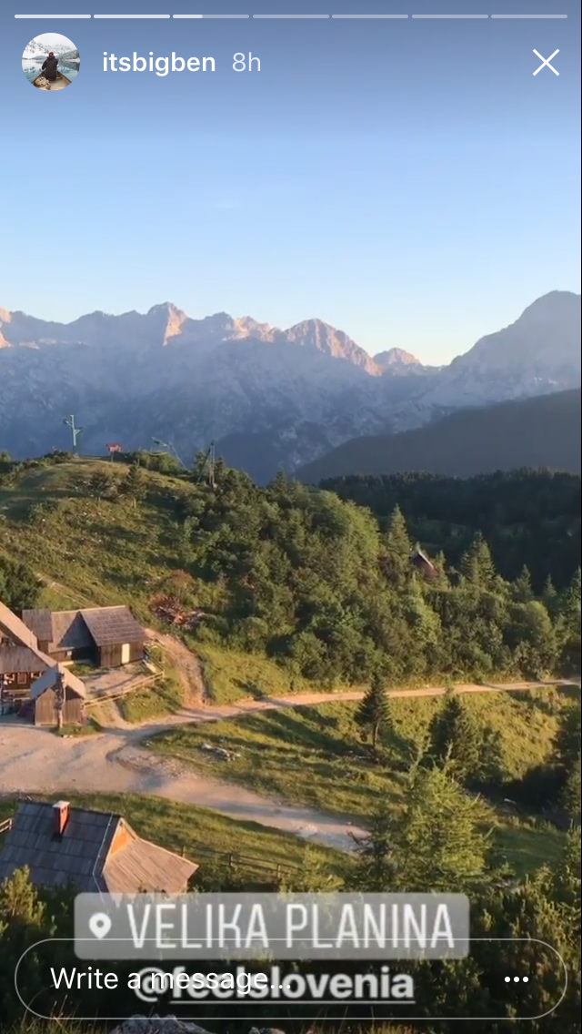

Check out their Instagram profiles and follow their daily adventure in Slovenia on Instagram Stories!
www.instagram.com/eevamakinen/
www.instagram.com/hannes_becker/?hl=en
www.instagram.com/daniel_ernst
www.instagram.com/dansmoe
www.instagram.com/michaelmatti/

www.instagram.com/jess.wandering/

www.instagram.com/vagabondhearts/

www.instagram.com/itsbigben/

