EMBARGOED UNTIL WEDNESDAY, 21 SEPTEMBER 2016

Slovenian Government, Tourism & Trade Delegation Conducts First Ever “Trade & Investment Mission” to the U.A.E

  - - Slovenian Minister of Economic Development and Technology His Excellency Zdravko Počivalšek heads largest Slovenian international trade delegation to any country to develop commercial networks and trade for mutual benefit with UAE partners -

[Dubai, 21 September 2016] Slovenia’s Ministry of Economic Development and Technology will commence its first ‘Trade and Investment Mission’ to the United Arab Emirates today, 21 September 2016, by holding a number of high level government and private business meetings, seminars and events with the UAE’s political and commercial elite. The mission is significant not only as it is the first such mission from Slovenia to visit the UAE, but for its size, which includes over 80 Slovenian industry and government leaders, representing almost 50 companies across 6 economic sectors, making it the largest Slovenian trade mission of its kind to GCC.

The initiative, led by the Slovenian Minister of Economic Development and Technology His Excellency Zdravko Počivalšek, will commence with an invitation only “I FEEL SLOVENIA EVENING” at the St. Regis Dubai on the evening of 21 September 2016, followed by a “UAE – SLOVENIA SEMINAR” to be held at the Dubai Chamber of Commerce on 22 September 2016. Seminar highlights will include a special address by His Excellency Sultan Bin Saeed Al Mansouri, UAE Minister of Economy, a keynote speech by the Slovenian Minister of Economic Development and Technology His Excellency Zdravko Počivalšek, and presentations by the Director General of the Slovenian Tourist Board Maja Pak, the Director of SPIRIT Slovenia (the Public Agency for Entrepreneurship, Internationalization, Foreign Investments and Technology) Gorazd Mihelič, and other Slovenian and Dubai commercial leaders. Following the seminar Slovenian delegates and the UAE’s business leaders will assemble for individual business meetings, including a business workshop specifically for the UAE’s leading travel agencies and Slovenian tourism sector partners.

Commenting on this historic occasion His Excellency Zdravko Počivalšek, Slovenian Minister of Economic Development and Technology noted: “This being the largest such business and trade delegation from Slovenia to GCC signifies the importance, commitment and expectations that Slovenia’s business elites have in building strong political, commercial and trade ties with the government and business leaders of the United Arab Emirates. Slovenia is a green, active, healthy, safe and smart land. We value these principles which have become the cornerstone of our tourism, technological, commercial and trade offering to the world. Just like the UAE we have a very clear vision for our future and we see this mission as the beginning of newly deepened bright and mutually beneficial relationship with the UAE.”

Chief Executive Offices and Directors from around 50 leading Slovenian companies are present in the delegation representing companies from various sectors including; Agriculture and Food Processing, the Electro Industry, Information and Communication Technologies, Interior Design, Engineering, and the largest participating sector with 24 companies, Tourism.

Slovenia is a world leader in sustainable development, signified by the country’s capital Ljubljana being awarded 2016 European Green Capital and demonstrated by Global Green Destinations Day, which will take place in Slovenia later this year. Slovenia is awarded as the fifth greenest country in the world while the country is also ranked as the 10th safest country in world based on the Global Peace Index 2016. Slovenia is also known as a country with clean environment, healthy lifestyle and rich with natural water. In fact, Slovenia has one of the cleanest waters in Europe and has 87 natural thermal and mineral water springs with 14 certified natural health resorts.
Details of the “UAE – SLOVENIA SEMINAR” are as follows:
Date: 22 September, 2016
Time: 09:00 am – 13:30 pm
Venue: Dubai Chamber of Commerce, Dubai, U.A.E.
For further details regarding the Slovenia Trade Mission please contact:
I FEEL SLOVENIA Middle East Office
C/- AVIAREPS Dubai
Tel: 04 3753 295
Email: Ifeelslovenia.me@aviareps.com
# # #
Notes to Editor

Photo Gallery:
Image 1: His Excellency Zdravko Počivalšek, Slovenian Minister of Economic Development and Technology
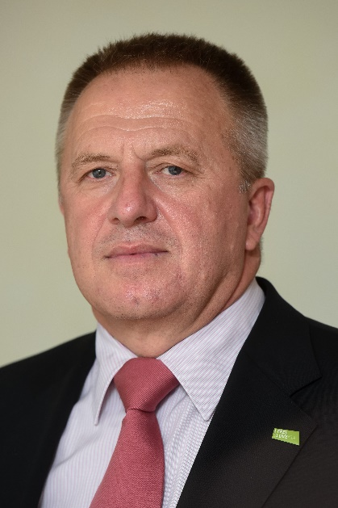

Image 2: Lake Bled, Slovenia
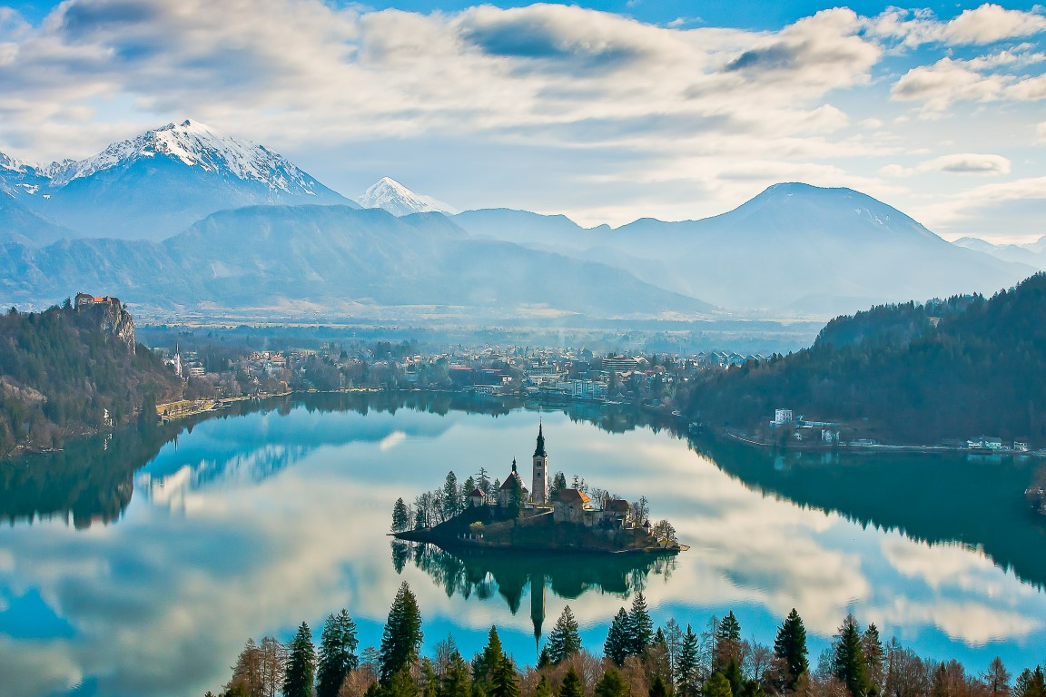

Image 3: Ljubljana, Slovenia
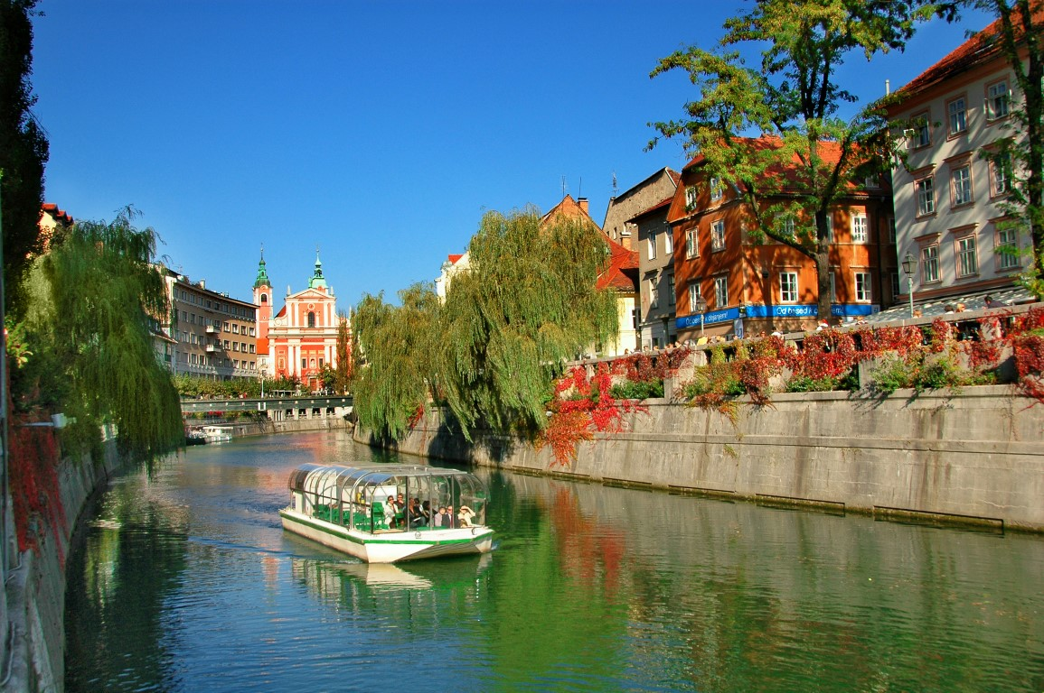
For high resolution images please click here

About the Slovenian Ministry of Economic Development & Technology
Ministry of Economic Development and Technology of the Republic of Slovenia is in charge of shaping the policy, promoting and implementing the measures in the field of entrepreneurship, competitiveness and technology, tourism and internationalization, trade policy, wood and furniture industry, internal market and regional development. The main objective of the Ministry is to support the further strengthening of international competitiveness of the Slovenian enterprises and an offensive restructuring of the Slovenian economy so that it becomes more adjusted to the demands of the global economy. www.mgrt.gov.si/en/

About Slovenia Tourist Board
The Slovenian Tourist Board (STB) is a major national tourist organization and central point in the complex network of the Slovenian tourism which plays a coordinating and linking role between the public, private and civil society. By using all the modern methods, approaches, tools and activities of global marketing, the STB aims to position Slovenia as a clearly and easily recognisable tourist country with precisely determined comparative and competitive advantages. The STB builds upon the relationship of partnership and has partners from private, public and civil areas of tourism. The relationship of partnership was transmitted to the marketing strategy and built into the whole process of planning, organizing and implementing promotional and marketing activities. www.slovenia.info

PRESS INQUIRIES
Ms. Hafsa Israr (+971 56 115 8116) or Mr. Ammar Adra (+971 52 956 4041)
Email: HIsrar@aviareps.com / AAdra@aviareps.com
Slovenian Tourist Board’s Promotional Office in Dubai & Middle East
Tel: + 971(4) 3753-296 Ifeelsloveniame@aviareps.com

