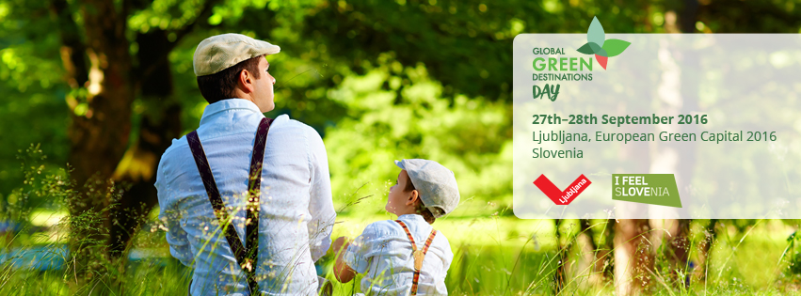

PRESS RELEASE

Slovenia has become the first Green Destination in the world, and Ljubljana has two placements among the TOP 100 Sustainable Destinations

Ljubljana, 27 September – Slovenia has become the first Green Destination in the world, and Ljubljana has two placements among the TOP 100 Sustainable Destinations. Other best practices of green and sustainable tourism in the world also received awards within the scope of the Global Green Destinations Day International Conference. Various Slovenian destinations and providers also celebrated their victories at the Ljubljana Castle.

Within the scope of the Global Green Destinations Day international conference, the awards for the best practices of the world's green and sustainable tourism were presented at the Ljubljana Castle. Destinations and providers of tourist services passed the assessment of their sustainable operations as per strict Green Destinations criteria based on international standards and the criteria of the Green Scheme of Slovenian tourism.

Together with the Slovenia Green Destination and Slovenia Green Accommodation quality brands, the Green Scheme was developed by the Slovenian Tourist Board in 2015. They are based on the Green Destinations standard in combination with the European Commission's ETIS tool, while the assessment is conducted on the basis of one hundred criteria. At today's ceremony, eight new winners of the Slovenia Green Destination quality brand were announced (these are: Nova Gorica, Brda, Kranjska Gora, Maribor, Ptuj, Slovenj Gradec, Bela krajina in Velenje) and three new holders of the Slovenia Green Accommodation award (the Celica Hostel, the Jožef Hotel and Pr'Gavedarjo – Rooms Design Rooms). Currently, there are 17 destinations (in addition to the above-stated, these are Ljubljana, Kamnik, Idrija, Rogla-Zreče, Radlje ob Dravi, Cerkno, Laško, Žalec, Celje) and 10 providers of tourist services (in addition to the new entrants there are also Ortenia-Apartments in nature, the Urška Tourist Farm, the Trnulja Estate, the Terme Snovik Spa, the Thermana Park Hotel in Laško, the Koren Camp in Kobarid and the Park Hotel in Ljubljana) included in the Green Scheme of Slovenian Tourism in total.

Today, destinations from 46 countries are receiving awards on the basis of the one hundred criteria assessment, as the one hundred most sustainable destinations in the world. The Top 100 Sustainable Destinations title was awarded to Ljubljana, which was on this list already in 2014, and to all destinations holding the Slovenian Green Destination certificate. Ljubljana was thus a two-time winner, since in 2015 it was the first holder of the Slovenia Green Destination quality brand.
In addition to Slovenia, the countries with the highest number of destinations on the list of the one hundred top sustainable destinations in the world are the Netherlands, Croatia, Portugal, Canada, Chile, China, Spain and Great Britain.

The Quality Coast award for the best sustainable coastal destination was also presented today at the Ljubljana Castle. There were 12 winners in this category, namely: Norderney (Germany), Alonnisos (Greece), Gozo & Comino (Malta), Ameland (the Netherlands), Noordwijk (the Netherlands), Azores (Portugal), Cascais (Portugal), Lagos (Portugal), Torres Vedras (Portugal), Regiao Oeste (Portugal), Baiona-Galicia (Spain) and Are (Sweden).

The highlight of the two-day Global Green Destinations Day international conference was reserved for Slovenia, which is the first country in the world to be comprehensively assessed in accordance with the Green Destinations standards. On the World Tourism Day, Slovenia was the first country in the world to receive the Green Destination award.
More information at: http://greendestinationsday.com.

Additional information

Slovenian Tourist Board
Dimičeva 13, SI-1000 Ljubljana, Slovenija
Tel.: 00386 (0)1 5898 550, Fax: 00386 (0)1 5898 560
www.slovenia.info/press
Maša Puklavec, Global Public Relations, press@slovenia.info

Ljubljana Tourism
Tel: 01 3064 593
Nina Kosin, Head of the Public Relations Office
nina.kosin@visitljubljana.si

