Slovenia media opportunities 2020
The Slovenian Tourism Board is delighted to work with journalists, and we hope you can visit and experience our amazing country for yourself.

There’s no “how to” guide - Slovenia is all about doing what comes naturally; whether you’re exploring the Alps, our Mediterranean coast, Pannonian Plain or the Karst – home to some of the most dramatic caves in the world.

Here are just a few examples of press trip opportunities and story ideas for the year ahead; we do hope you can join us…
Tackle the NEW Julian Alps Hiking Trail
In October 2019 Slovenia unveiled a new 270km hiking trail through the mighty Julian Alps. This new circular route will lead walkers from the state border between Italy and Slovenia via numerous natural wonders including the Kranjska Gora region, the Sava River and the Soca Valley. It will also encompass the shores of Lake Bled before a challenging ascent into the Triglav National Park under the shadow of mighty Mt Triglav. Other highlights include the Bohinj region and Slovenia’s sweetest town, Radovljica, where the country’s famous Lectar, or decorated gingerbread, is made.

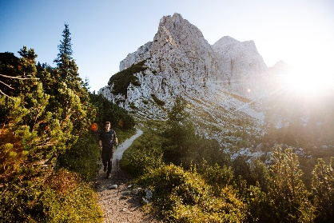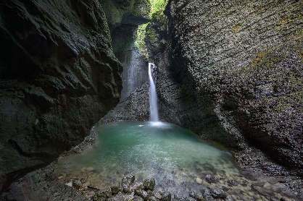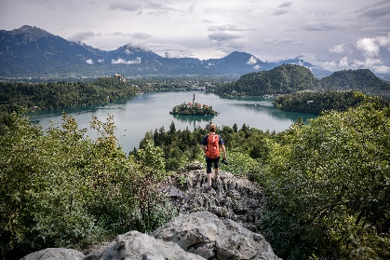

Explore the European Region of Gastronomy 2021
Having been named European Region of Gastronomy 2021, Slovenia will be focusing heavily on culinary adventures in 2019 & 2020 and celebrating some of its brightest culinary stars including Igor Štefelin at Vila Podvin, Igor Jagodic at Strelec (Gault & Millau 2019 Chef of the Year) and avant-garde chef David Vračko (Gault & Millau Chef of the Future). From world-class restaurants, events and culinary tours to gastronomic adventures including mountain biking through vineyards and truffle hunting through the forests of Istria, this will be the year to uncover Slovenia’s diverse and delicious foodie adventures.
Visit iconic wine regions and see the world’s oldest vine in Maribor or explore Goriska Brda, home to an abundance of local produce including olives, figs and cherries, as well as the Rebula Masterclass event in August. In March 2020 you’re invited to mingle with some of Slovenia’s brightest culinary stars at the European Food Summit in Ljubljana. Hope you’re hungry!

NEW for 2020: Chocolate Glamping & world’s first green bike trail
2019 saw the unveiling of Pohorje Treetop Walk, a new fully accessible nature experience structure that stretches up to 39 metres above the treetops and offers a 360-degree view over the mountain peaks and valleys of the Pohorje Mountains. November also saw the launch of ‘Bike Slovenia Green’, the world's first long-distance, multi-stage itinerary that exclusively connects green-certified locations.

New accommodations opening this year include the Chocolate Village glamping resort near Maribor where you can combine accommodation in a luxury treehouse with all manner of chocolate-based activities including workshops, cosmetics and massage. There’s also the new Sunrose 7 eco-hotel, originally built in 1890 and now transformed into an 18-room boutique ‘adults only digital detox hideaway’.

Enjoy 5* Slovenian Unique Experiences
New for 2019 the Slovenian Tourism Board have unveiled a collection of ’Slovenia Unique Experiences’ - boutique five-star adventures that can’t be enjoyed anywhere else. Come and experience Slovenia’s originality in an unforgettable way with tailor-made experiences including kayaking through the flooded underground tunnels of Mount Pecca and an eco-treehouse holiday overlooking Lake Bled.
You can also walk in the footsteps of ancient underground explorers as you learn about the rich biodiversity of the famous Postojna Cave system - you may even get to meet an iconic ‘baby dragon’! There’s also the opportunity to enjoy the finest culinary adventures, from a classic car journey through Istria’s olive groves to a world-class gastronomic journey 160 meters below the earth’s surface.

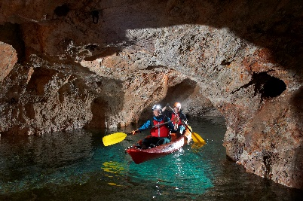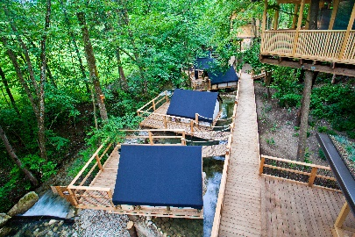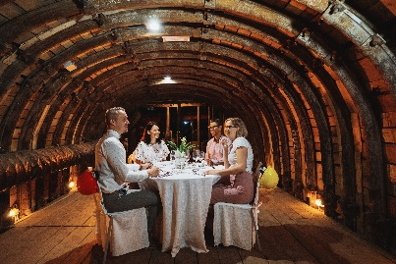

Enjoy a little Luxury: New boutique hotels for 2020
Experience a little luxury in 2020 by exploring Slovenia’s boutique hotels. New offerings for 2020 include Vila Planinka, a luxury boutique hotel in Jezersko. Surrounded by four ancient natural energy points, the hotel also boasts natural air conditioning via the Skuta glacier and the Jezersko mineral water just a short walk away. Other new openings and renovations for 2020 include Majerca which overlooks beautiful Lake Bohinj, and the newly-renovated Hotel Plesnik, offering a variety of wellness and outdoor adventure packages .

As a global leader in sustainable tourism, Slovenia is proud to offer eight naturally and culturally diverse destinations recognised by the European EDEN network. Podčetrtek, one of Slovenia’s finest wellness destinations, was named EDEN’s ‘wellness tourism’ winner in 2019. For more information visit: www.slovenia.info/en/stories/eight-destinations-of-excellence-in-slovenia

AM+A will be managing a range of media group and individual trips in 2020, organised by the Slovenian Tourism Board with special support for freelancers, bloggers and vloggers.
To register your interest in a trip please email slovenia@alexandramarr.com with the subject line ‘WTM Press Trip Opportunity’.

Additional information

Slovenian Tourist Board
Maša Puklavec, Global PR Manager, press@slovenia.info

Follow and visit us

FOLLOW US  www.slovenia.info/facebook  www.slovenia.info/twitter  www.slovenia.info/linkedin  www.slovenia.info/youtube  www.slovenia.info/instagram  www.slovenia.info/googleplus  www.slovenia.info/pinterest  www.slovenia.info/tripadvisor | - Visit the official SLOVENIAN TOURIST INFORMATION PORTAL: www.slovenia.info  - Visit our PRESS CENTRE, follow the news (press releases) and monthly news for journalists: www.slovenia.info/press  - Sign up for MONTHLY NEWS FOR MEDIA: www.slovenia.info/news  - Visit our MEDIA LIBRARY, where you can view and use more than 3000 high-resolution photos and videos of Slovenian tourism: www.slovenia.info/en/media-library/photo

